Colin C. Thompson, PCC, CPQC
Professional Speaker | TEDx Speaker | Coach
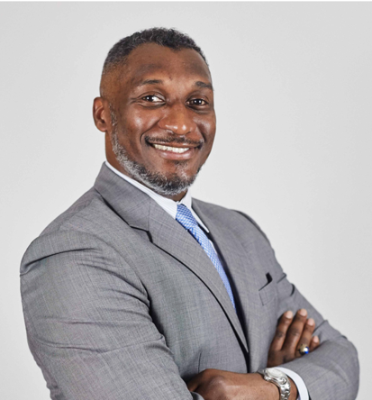
Profile
Colin C. Thompson is a professional speaker who challenges audiences to think differently, take ownership, and perform at their best under pressure. With over 20 years of experience across consulting, coaching, and facilitation, he brings practical insight and real-world perspective to every stage.

Speaking Experience
- TEDx ShiBoCun Road 2025
- Black Blockchain Summit (2019–2024)
- TiD Innovation Conference (2022–2025)
- Asia Professional Speakers Singapore
- UXPA World Usability Day
Speaking and Event Contributions
- TEDx ShiBoCun – Host
- BizWorld Inc. – Judge
- Toastmasters – Organizer
- The Expatriate Center – Contest Team and Speaker Coach
Focus Areas
- Mindset & Mental Fitness
- Leadership & Ownership
- Performance Under Pressure
- Communication & Public Speaking

Publications
Co-author, Voices of Leadership Volume 2: A collaborative exploration of leadership insights and strategies for success.

Contact Information
Email: ColinT@oligye.com | LinkedIn: linkedin.com/in/colincthompson | www.ColinCThompson.com

